PROJECT REPORT
Pixhawk-Based Quadcopter
Assembly, Configuration, Calibration and Flight Testing
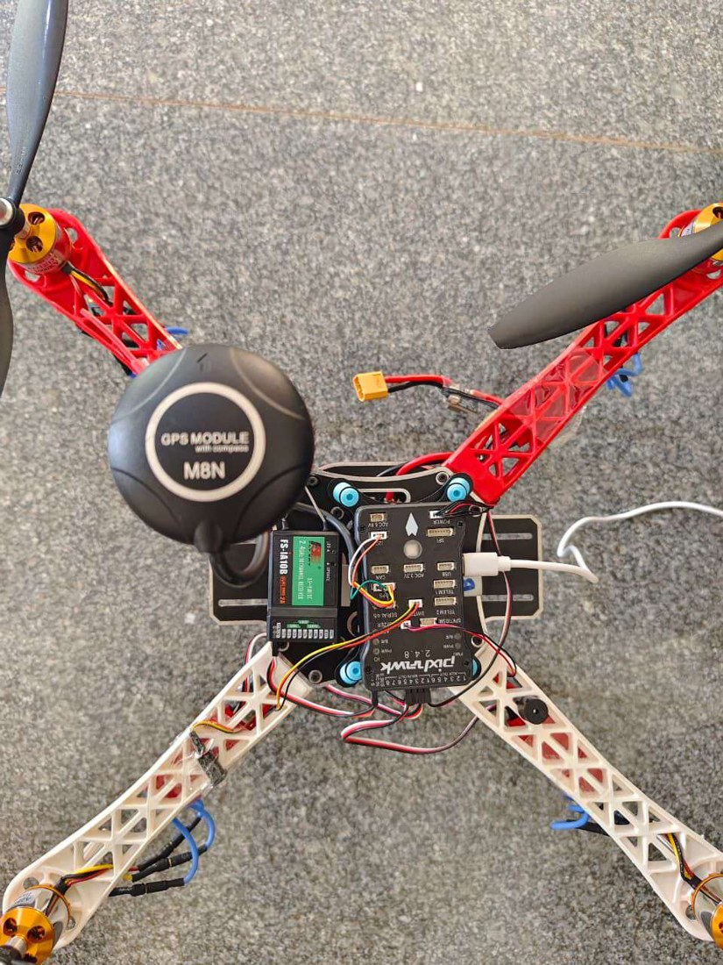
Table 1: Project at a glance
Item | Details
Flight controller | Pixhawk 2.4.8 running ArduCopter V4.7.1
Airframe | Quadcopter, X configuration; 4 × A2212/13T 1000 KV motors, 4 × 35 A ESCs, 10 × 4.5 in propellers
Radio system | FlySky FS-i6S transmitter, FS-iA10B receiver (PPM)
Navigation | M8N GPS module with compass
Power | 3S lithium-ion battery (11.1 V nominal, 12.6 V full)
Ground software | Mission Planner 1.3.83
Flight modes | Stabilize, Loiter, Return to Launch (RTL)

Abstract
This report documents the complete build of a quadcopter around a Pixhawk 2.4.8 flight controller, from soldering the main plate to the first test flights. The work covered mechanical assembly, wiring of four brushless DC (BLDC) motors and their electronic speed controllers (ESCs), installation of a GPS and compass module, and setting up a FlySky FS-i6S transmitter with an FS-iA10B receiver.
In Mission Planner the firmware was installed, the frame type chosen, and the accelerometer, compass, radio and ESCs calibrated. Flight modes, failsafes and initial tuning parameters were then set, and the motors were tested for rotation direction. Each calibration is presented as a block diagram supported by photographs and screenshots taken during the project. The report closes with the flight procedure, the problems met and how they were solved, safety precautions and ideas for future work.

Contents
1. Introduction 4
2. Drone Overview 4
3. Working Principle 6
4. Components 6
4.1 Frame 6
4.2 Battery 7
4.3 Motors and ESCs 7
4.4 Propellers 7
4.5 Pixhawk 2.4.8 flight controller 8
4.6 Power module 8
4.7 GPS and compass 9
4.8 Transmitter and receiver 9
4.9 Other items 10
5. Mechanical Assembly 10
6. Electrical Wiring 12
7. FlySky Transmitter Setup 14
8. Mission Planner Setup and Calibration 17
8.1 Connecting to the Pixhawk 18
8.2 Installing the firmware 18
8.3 Frame type 19
8.4 Accelerometer calibration 19
8.5 Compass calibration 20
8.6 Radio calibration 21
8.7 ESC calibration 22
8.8 Flight modes 23
8.9 Failsafe 24
8.10 Initial tune parameters 25
8.11 Motor test 26
9. Flight Procedure 27
10. Problems Faced and Solutions 29
11. Safety Precautions 30
12. Conclusion 30
Appendix: Values to Confirm Before Submission 30

1. Introduction
The aim of this project was to assemble, configure, calibrate and test a quadcopter built around the Pixhawk flight controller. The work combined frame assembly, electrical wiring, radio setup, sensor calibration and flight testing using the open-source ArduPilot firmware and the Mission Planner ground-station software.
The drone is controlled with a FlySky FS-i6S transmitter and FS-iA10B receiver. Three flight modes were configured on one three-position switch: Stabilize for manual flight, Loiter for GPS position hold and Return to Launch (RTL) for automatic return.

1.1 Objectives
- Assemble the frame and mount the motors, ESCs, Pixhawk, GPS and receiver.
- Wire the power and signal connections correctly.
- Configure the transmitter and bind it to the receiver.
- Calibrate the accelerometer, compass, radio and ESCs, and verify motor rotation.
- Set flight modes, failsafes and initial tuning parameters in Mission Planner.
- Test Stabilize, Loiter and RTL in flight.

1.2 Project workflow
The project followed the eight stages in Figure 1. The order matters: for example, ESC calibration and motor tests must be finished, with propellers removed, before the first flight.
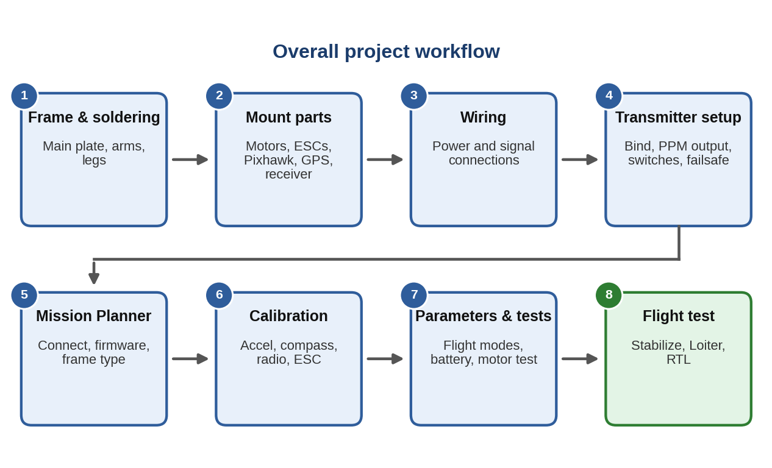
Figure 1: Overall project workflow.

2. Drone Overview
The drone is a small quadcopter in X configuration. It was built from a ready-made kit with a Pixhawk 2.4.8 flight controller. Table 2 lists the main specifications and Figure 2 shows the finished airframe from above.
Table 2: Main specifications
Parameter | Value
Type | Quadcopter (multirotor), X configuration
Weight | About 2.5 kg all-up without payload
Payload | Up to about 1 to 1.5 kg (reported)
Operating height | Flown up to 60 ft (about 18 m); capable of about 100 ft (30 m)
Radio range | Reported as 2 to 3 km; flights were kept within visual line of sight
Flight controller | Pixhawk 2.4.8, ArduCopter V4.7.1
Radio | FlySky FS-i6S transmitter (Mode 2) and FS-iA10B receiver, PPM output
Positioning | M8N GPS with external compass
Battery | 3S lithium-ion, 11.1 V nominal, 12.6 V fully charged
Motors and ESCs | A2212/13T 1000 KV BLDC motors; 35 A ESCs
Propellers | 10 × 4.5 in (marking 1045), one clockwise and one anticlockwise type
Ground software | Mission Planner 1.3.83

Figure 2: Top view of the assembled quadcopter: red arms at the front, white arms at the rear, Pixhawk and receiver on the centre plate, GPS on its mast.
Regulatory note. India’s Drone Rules, 2021 classify drones by maximum all-up weight including payload. A drone above 2 kg and up to 25 kg is a “small drone”. At about 2.5 kg plus a payload of up to 1.5 kg, this drone is therefore in the small category, not a micro drone. Educational institutions flying a drone for research and development are exempt from the type certificate, UIN, prior permission and remote pilot licence, but only inside a green zone and within the premises where the research is carried out. Always check the Digital Sky zone map and the current rules before flying.

3. Working Principle
A quadcopter has no moving control surfaces. It is steered only by changing the speed of its four motors. The Pixhawk reads the pilot’s commands from the receiver together with its own sensors (gyroscope, accelerometer, compass, barometer and GPS), calculates the speed each motor needs and sends that command to the ESCs. The ESCs drive the motors from the battery. Because the sensors report back many times per second, the loop corrects itself continuously.
Two motors spin clockwise and two anticlockwise, with each diagonal pair spinning the same way, so that their reaction torques cancel and the drone does not rotate by itself. Changing the balance between the motors produces movement (Table 3).
Table 3: How motor speed changes produce movement
Pilot command | Motor speed change | Result
Throttle up | All four motors speed up | Drone climbs
Pitch forward | Rear motors speed up, front motors slow down | Nose tips down, drone moves forward
Roll right | Left motors speed up, right motors slow down | Drone tilts and moves right
Yaw | One diagonal pair speeds up, the other slows down | Drone turns on the spot

Figure 3 shows how the parts are connected. Two different signal types are used: the receiver sends PPM to the Pixhawk RC IN port, and the Pixhawk sends PWM to each ESC from its MAIN OUT pins.
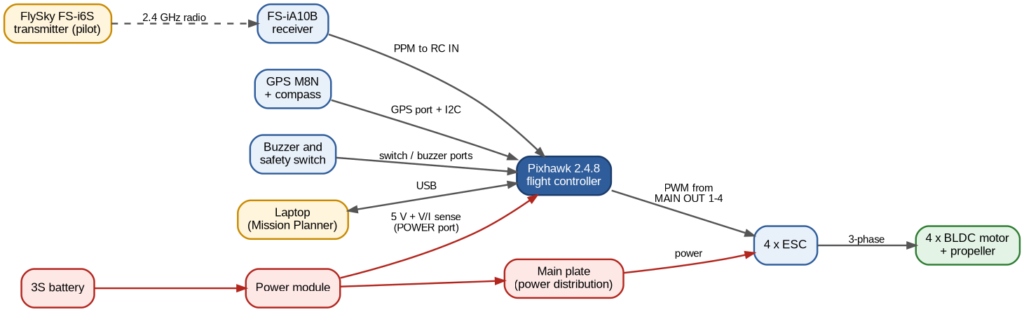
Figure 3: System block diagram. Red lines carry battery power; grey lines carry signals.

4. Components

4.1 Frame
The frame has four arms, a black main plate and four landing legs. The main plate is a printed circuit board (PCB) with built-in power distribution tracks, so the ESC and battery leads are soldered directly to it. A second plate above it carries the flight controller. Two arms are red and two are white: the red arms mark the front and the white arms the rear.
Frames of this class are normally made from glass-fibre-reinforced nylon (polyamide) for the arms and legs and glass-fibre PCB material (FR4) for the plates. This gives a light, stiff and low-cost airframe. Confirm the exact material from the kit datasheet.

4.2 Battery
The drone is powered by a three-cell (3S) lithium-ion battery. The cell count can be confirmed from the thin balance lead: a 3-cell pack has four wires on its balance connector (one common negative plus one per cell). The ratings are in Table 4.
Table 4: Battery specification
Parameter | Value
Cells | 3S (three cells in series)
Nominal voltage | 11.1 V (3.7 V per cell)
Fully charged voltage | 12.6 V (4.2 V per cell)
Capacity | 5200 mAh (reported; confirm from the label)
Burst discharge | Up to 15 A (reported; confirm from the label)

4.3 Motors and ESCs
Four A2212/13T 1000 KV brushless DC motors produce the thrust. KV is the motor speed in revolutions per minute for each volt applied with no load. Each motor is driven by its own 35 A electronic speed controller (ESC), which converts the PWM command from the Pixhawk into three-phase power for the motor. Swapping any two of the three motor wires reverses the motor direction.

4.4 Propellers
Two types of propeller are used: one for motors that turn clockwise and one for motors that turn anticlockwise. Both push air downward to create lift. The marking 1045 means a 10 inch diameter and a 4.5 inch pitch (the distance the propeller would advance in one turn). Propellers are marked differently for the two directions (for example with or without the letter R), so check each one against the motor it is fitted to and make sure it pushes air downward.
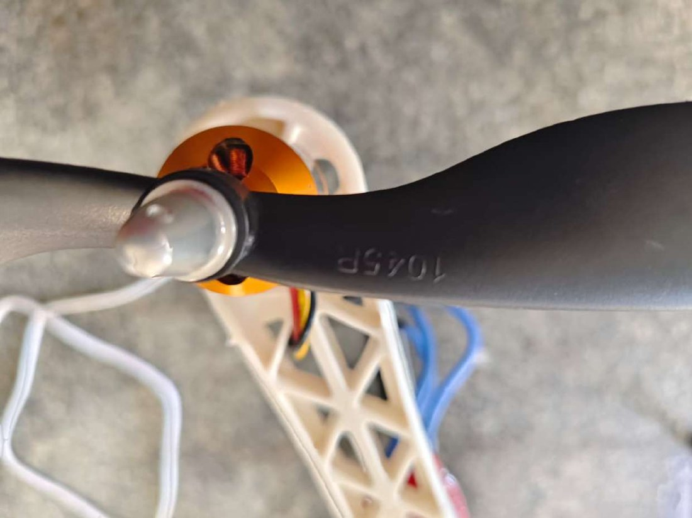  Figure 4: Propeller marked 1045 on one blade. | 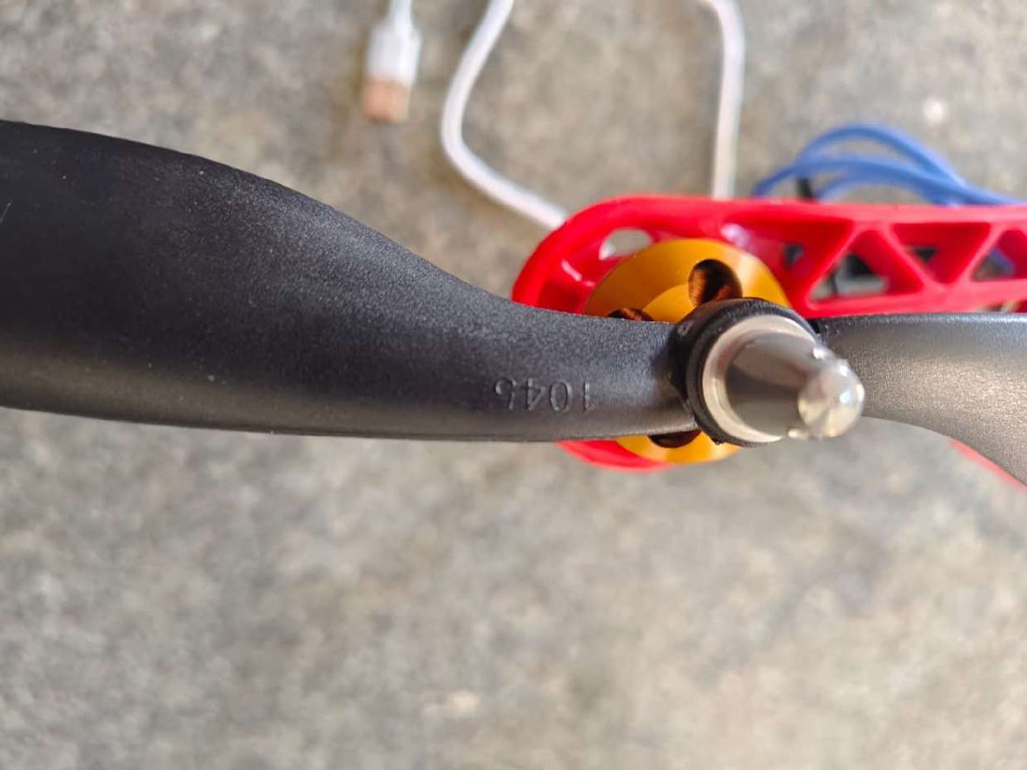  Figure 5: Second propeller type, also 1045 (10 in diameter, 4.5 in pitch).

4.5 Pixhawk 2.4.8 flight controller
The Pixhawk is the brain of the drone. It contains the 32-bit processor, gyroscopes, accelerometers, a compass and a barometer, and runs the ArduCopter firmware. Its MAIN OUT pins drive the ESCs, RC IN accepts the receiver signal, and separate ports accept the GPS, I²C compass, buzzer, safety switch and power module. It sits on a vibration-damping plate with blue rubber mounts and must point forward, with its arrow toward the front (red) arms.
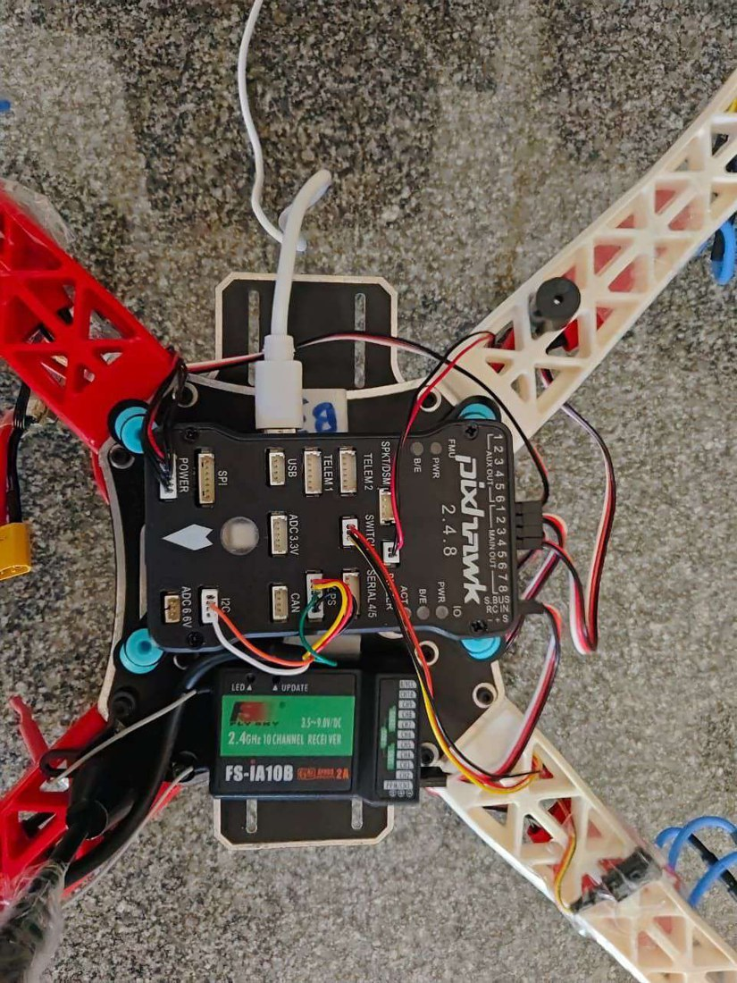
Figure 6: Pixhawk 2.4.8 on its damping plate, with the receiver beside it and the GPS and power cables connected.

4.6 Power module
The power module sits between the battery connector and the main plate. It provides regulated 5 V to the Pixhawk and measures battery voltage and current so that Mission Planner can display them and trigger battery failsafes.
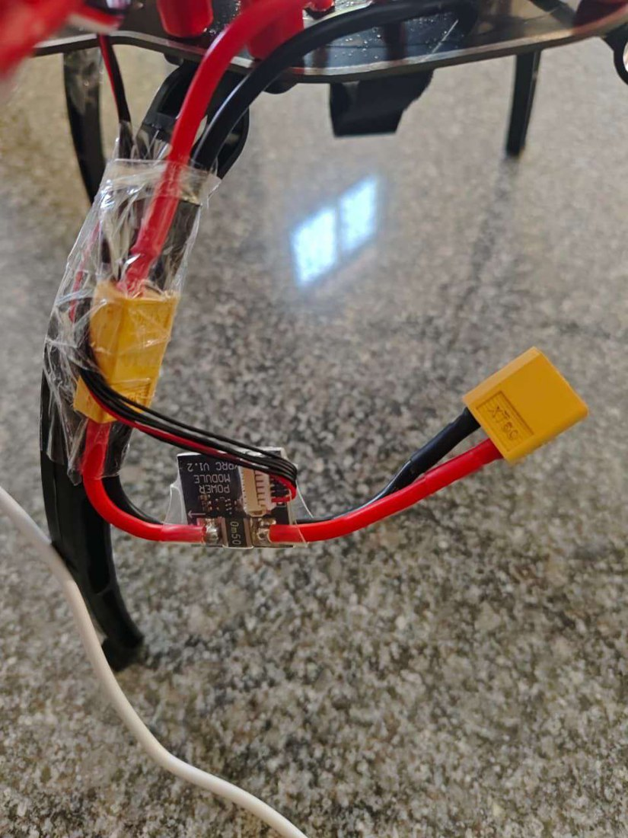
Figure 7: Power module wired between the XT60 battery connector and the main plate.

4.7 GPS and compass
The M8N GPS module includes a compass. It works outdoors only: it needs a clear sky view and should have at least 8 satellites before flight. Fewer satellites give a poor position and unreliable Loiter and RTL. It is mounted on a mast away from power wires, with its arrow pointing the same way as the Pixhawk arrow.

4.8 Transmitter and receiver
The FlySky FS-i6S is a 2.4 GHz transmitter with two sticks and four switches: SwA and SwD have two positions, and SwB and SwC have three. The FS-iA10B is a 10-channel receiver that accepts 3.5 to 9.0 V and outputs PPM or i-BUS. It has two antennas, which are placed at right angles to each other for better reception.
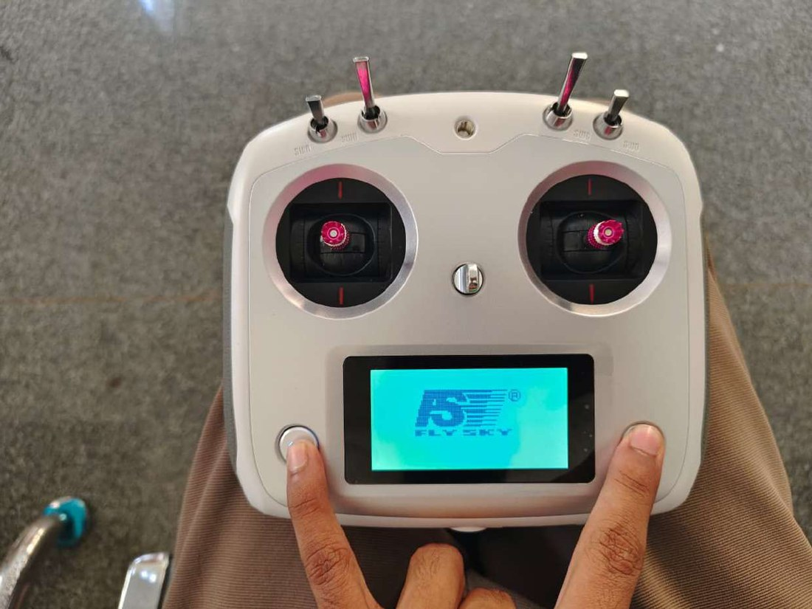
Figure 8: FlySky FS-i6S transmitter being switched on by pressing both power keys together.

4.9 Other items
Table 5: Other components
Item | Purpose
Buzzer | Gives audible status, arming and warning tones
Safety switch | Must be pressed before the motors can be armed
Memory card and USB cable | Stores logs; the USB cable connects the Pixhawk to the laptop
Cable ties, tape, foam and Velcro | Secure the ESCs, wires and battery
Soldering tools, Allen keys | Used for assembly

5. Mechanical Assembly
The electrical connections on the main plate are soldered first because they are much easier to reach before the arms and other parts are fitted (Figure 9).
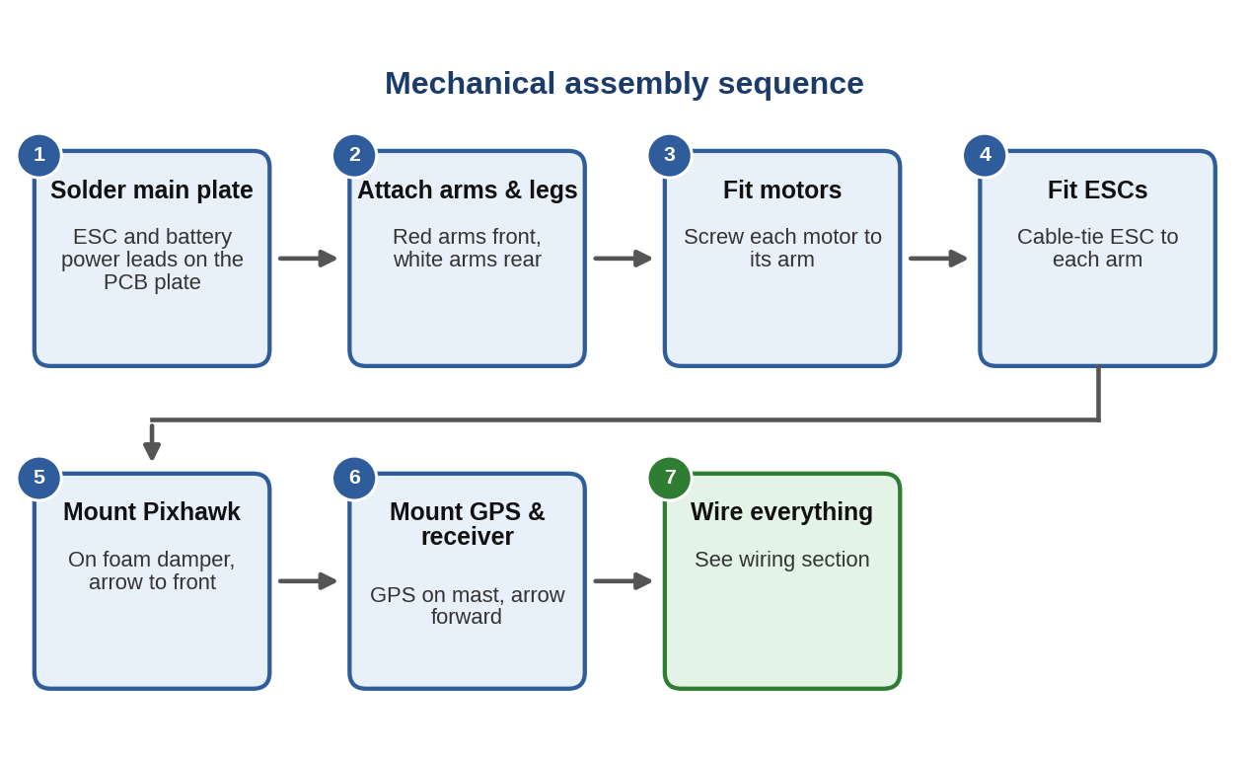
Figure 9: Mechanical assembly sequence.

Step 1: Soldering the main plate
Solder the ESC power leads and the battery lead to the main plate. A good joint is smooth, shiny and rounded and covers the whole pad, forming a small mound over the wire. A poor joint can fail under high current, so check each one for strength and for short circuits.

Step 2: Arms and legs
Screw the four arms and the landing legs to the main plate. Fit the two red arms at the front and the two white arms at the rear. Attach the upper plate above the main plate.

Step 3: Motors
Screw one motor to the end of each arm. Note the arm colour and position of each motor, because motor numbers and directions depend on it (Section 6).

Step 4: ESCs
Fix one ESC to each arm with cable ties or tape and connect it to its motor.
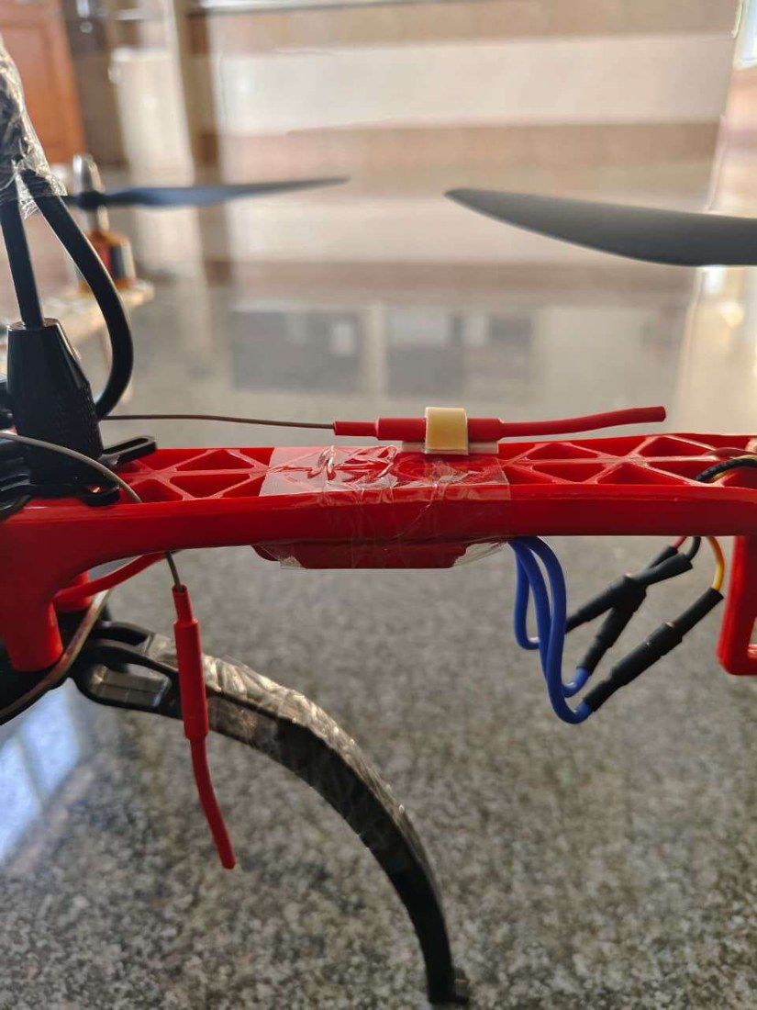
Figure 10: An ESC secured to an arm. The blue leads are the three motor phase wires; the receiver antenna is also routed along the arm.

Step 5: Pixhawk and receiver
Place the damping plate with its blue rubber mounts on the upper plate, mount the Pixhawk on it with the arrow pointing forward, and mount the receiver beside it.

Step 6: GPS
Fix the GPS mast to the frame and point the GPS arrow forward.
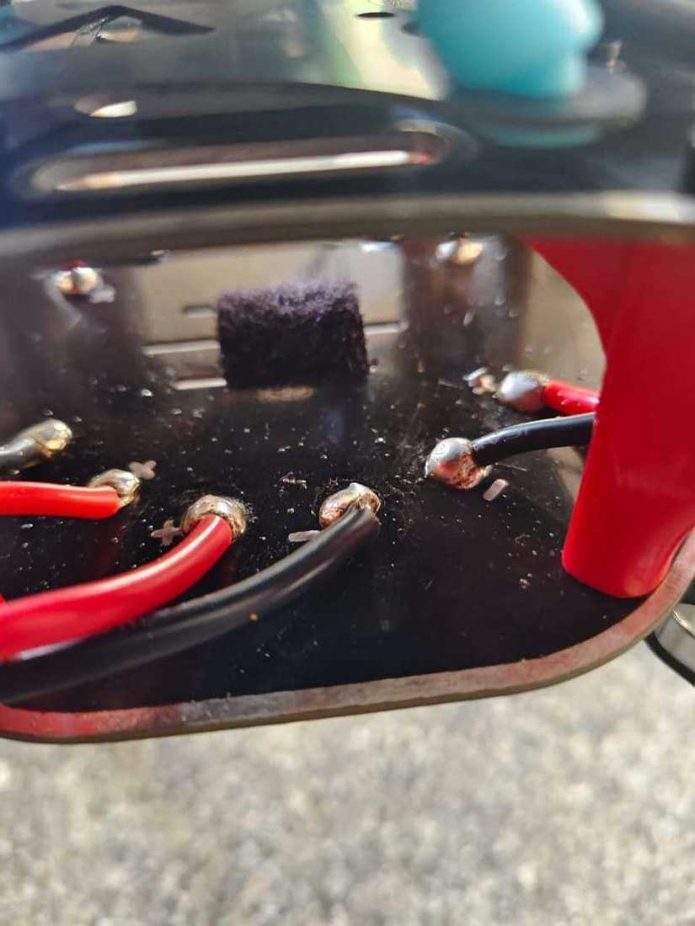
Figure 11: Wires soldered to the main plate. Each joint must be solid, because high current flows through them.
Tip. Tighten all screws and propeller nuts. Thrust and vibration can loosen them, and this happened during testing.

6. Electrical Wiring
The power path (battery, power module, main plate, ESCs, motors) and the signal path (Pixhawk, ESCs, receiver, sensors) are wired separately. Table 6 lists every connection. Figure 12, Figure 13 and Figure 6 show the Pixhawk ports used.
Table 6: Wiring summary
From | To | Signal / port
Battery connector | Power module, then main plate | Main power
Main plate | 4 ESCs | ESC power
4 ESCs | 4 BLDC motors | Three-phase motor wires
4 ESC signal leads | Pixhawk MAIN OUT 1 to 4 | PWM motor commands (AUX OUT is not used)
FS-iA10B receiver | Pixhawk RC IN | PPM
GPS module | Pixhawk GPS port | GPS data (this GPS does not use CAN)
Compass (in GPS module) | Pixhawk I²C port | Compass data
Power module | Pixhawk POWER port | 5 V supply, battery voltage and current
Buzzer, safety switch | Pixhawk buzzer and switch ports | Alerts and arming safety

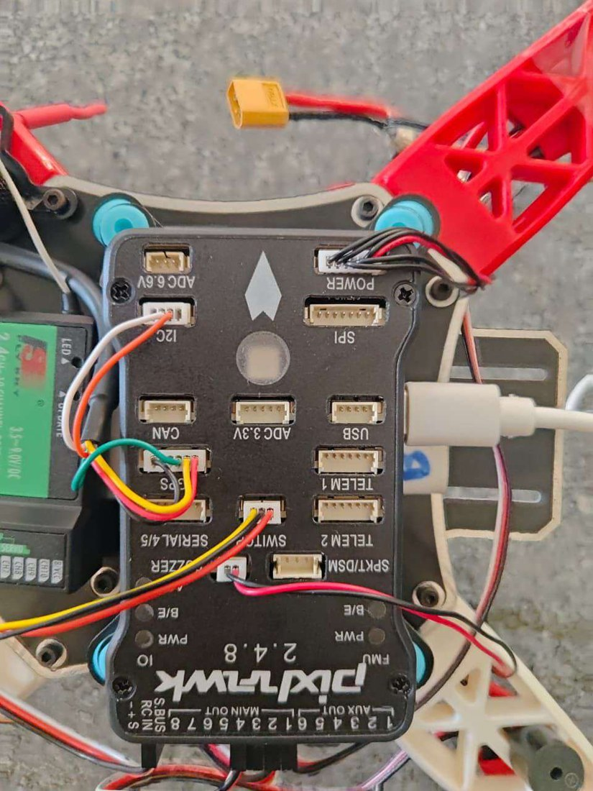  Figure 12: Pixhawk ports with receiver, GPS, I²C and switch leads. | 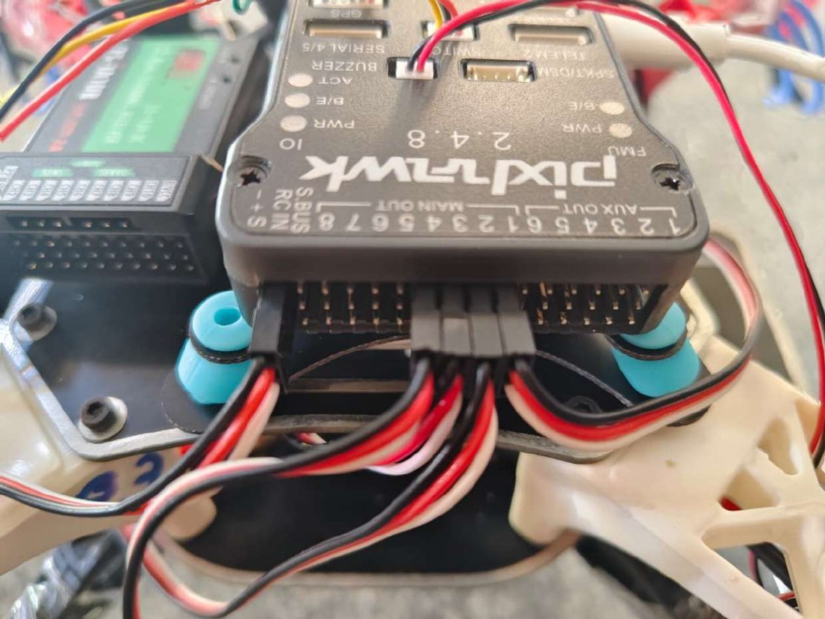  Figure 13: ESC signal leads on MAIN OUT 1 to 4 and the receiver lead on RC IN.

PPM and PWM. PPM carries all the pilot’s channels on one wire from the receiver to the Pixhawk RC IN port. PWM is the signal from the Pixhawk MAIN OUT pins to each ESC. The AUX OUT pins also give PWM but are meant for other equipment such as servos or a camera gimbal, so ESCs must not be connected there.

6.1 Motor numbering and direction
The motors follow the ArduPilot Quad-X layout (Figure 14 and Table 7). Motor 1 is front-right, and diagonal motors turn in the same direction.
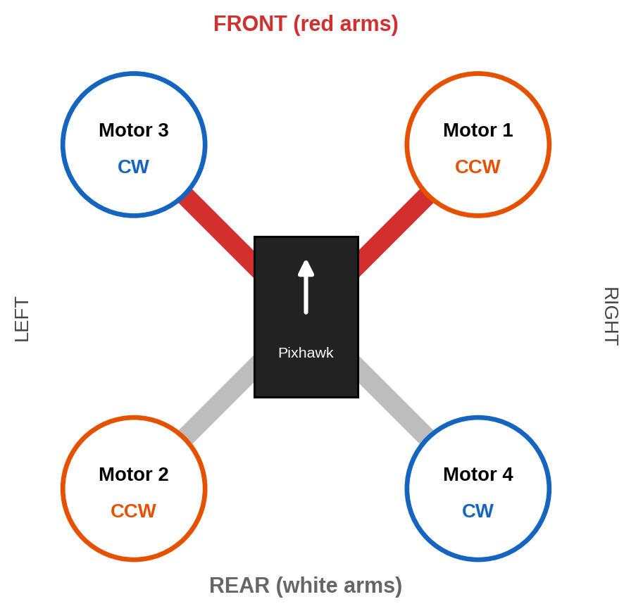
Figure 14: Quad-X layout viewed from above, with motor numbers and required rotation.
Table 7: Required motor positions and rotation
Motor | Position | Arm colour | Rotation
Motor 1 | Front-right | Red | Anticlockwise (CCW)
Motor 2 | Rear-left | White | Anticlockwise (CCW)
Motor 3 | Front-left | Red | Clockwise (CW)
Motor 4 | Rear-right | White | Clockwise (CW)

7. FlySky Transmitter Setup

7.1 Binding the receiver
The transmitter and receiver must be bound so that the receiver only accepts commands from this transmitter. Figure 15 shows the process.
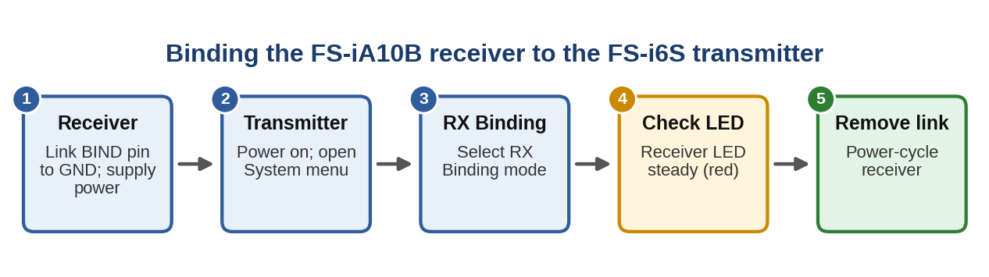
Figure 15: Binding process.

7.2 Transmitter configuration
Figure 16 shows the order of setting the transmitter. Before starting, put all switches in their upper position, then switch on by pressing both power keys together.
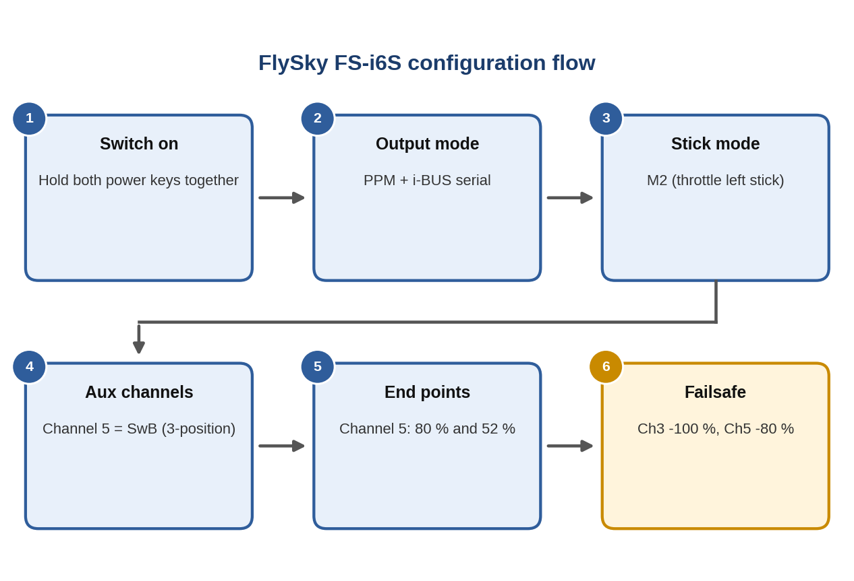
Figure 16: Transmitter configuration flow.
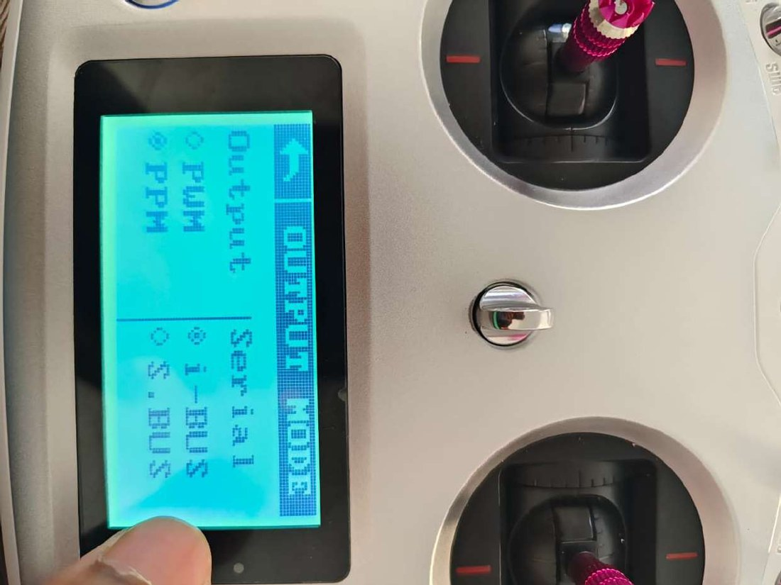  Figure 17: Output mode: PPM with i-BUS serial. | 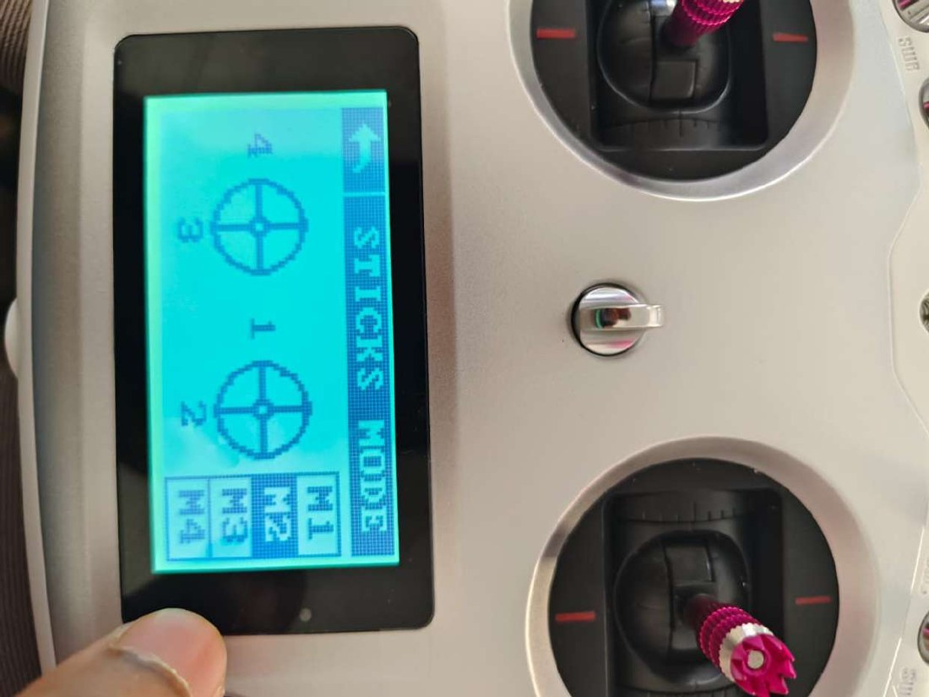  Figure 18: Stick mode set to M2: throttle on the left stick.

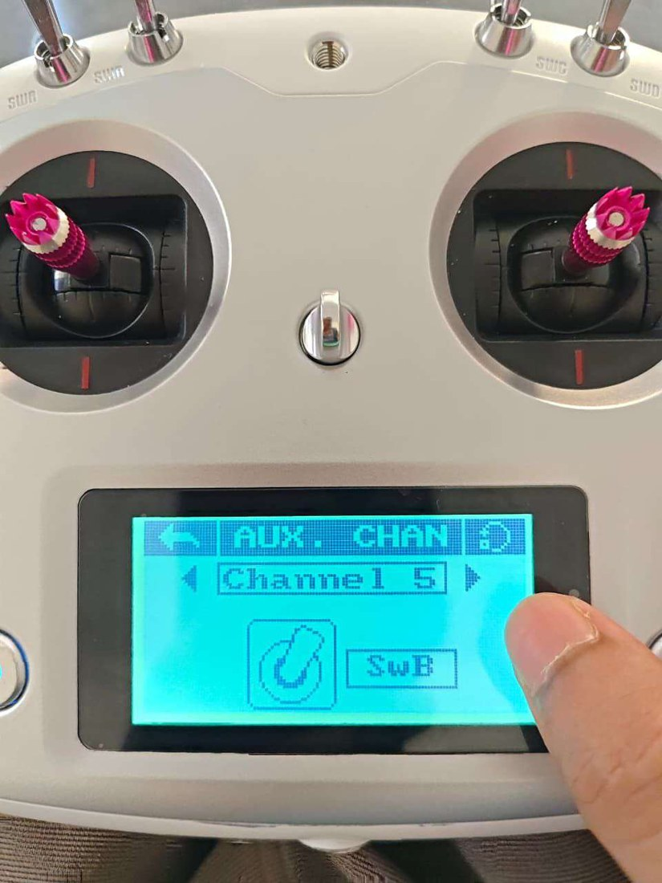  Figure 19: Aux. channels: Channel 5 assigned to switch SwB. | 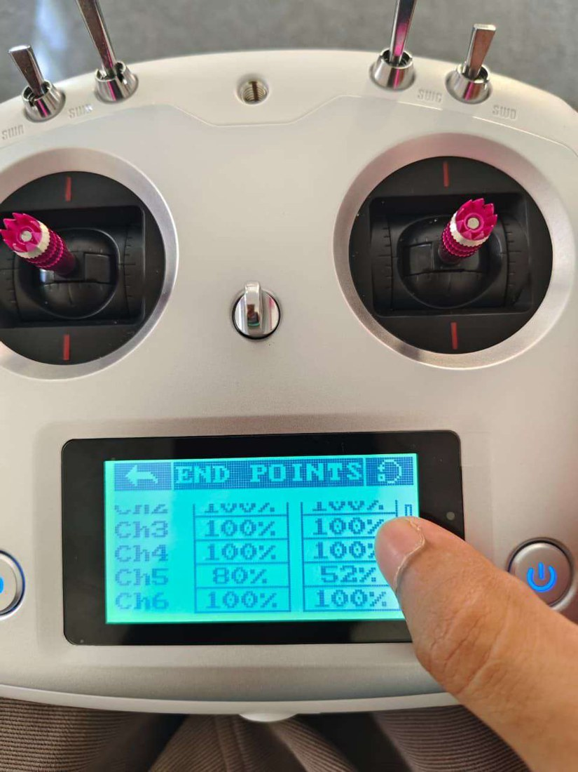  Figure 20: End points: Channel 5 set to 80 % and 52 %.

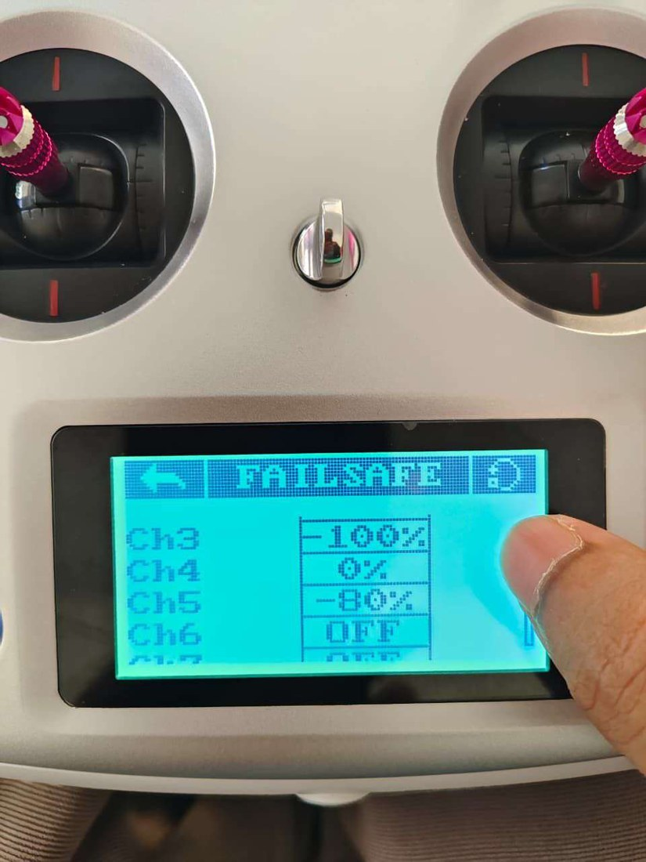  Figure 21: Failsafe: Channel 3 at −100 %, Channel 5 at −80 %. | 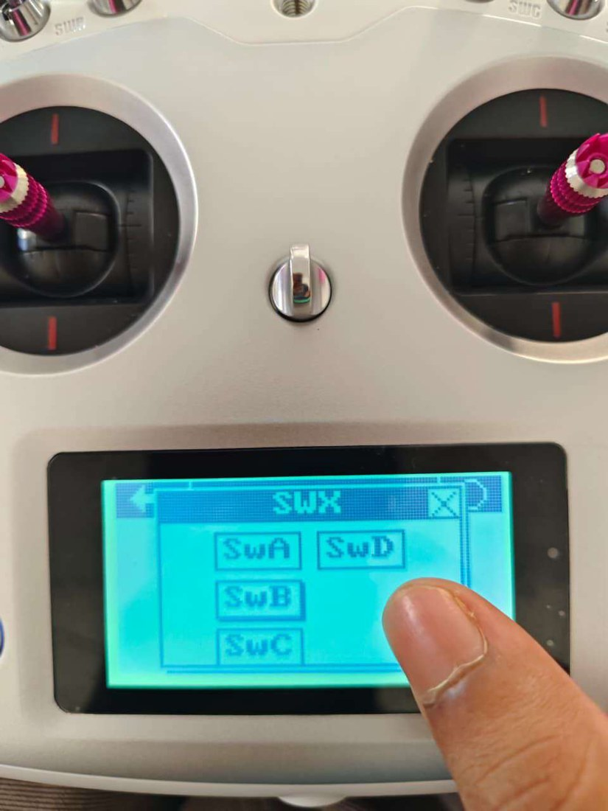  Figure 22: Switch choices SwA to SwD for a channel.

Table 8: Transmitter settings used
Setting | Value
Output mode | PPM (receiver to Pixhawk); i-BUS serial
Stick mode | M2: throttle and yaw on the left stick, pitch and roll on the right
Flight-mode switch | SwB (three positions) assigned to Channel 5
Channel 5 end points | 80 % and 52 % at the two ends of the switch travel
Failsafe | Channel 3 (throttle) −100 %, Channel 5 −80 %, other channels off or 0 %

Why the end points matter. The Pixhawk chooses the flight mode from the PWM value of Channel 5 (Table 9). Setting the end points to 80 % and 52 % places the three switch positions inside the Stabilize, Loiter and RTL bands. After setting them, check the live PWM value on the Mission Planner Flight Modes page (Section 8.8).

Failsafe. The transmitter failsafe values only trigger an action if the matching throttle and radio failsafe options are enabled in Mission Planner (Section 8.9).

8. Mission Planner Setup and Calibration
Mission Planner is the ground-station program used to load firmware and configure the Pixhawk. The recommended order is shown in Figure 23. Accelerometer, compass and ESC procedures are done with the propellers removed, and the compass is calibrated outdoors.
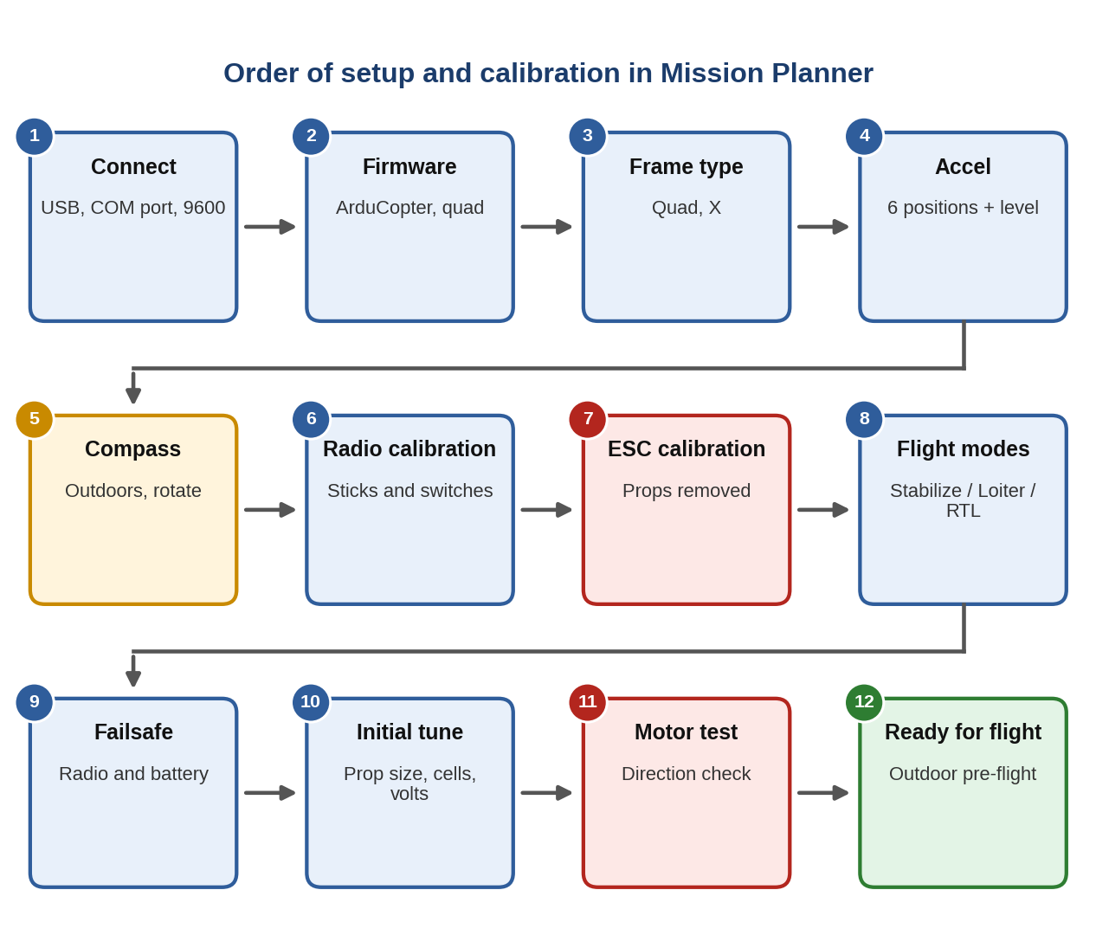
Figure 23: Order of setup and calibration. Red boxes need the propellers removed; the amber box must be done outdoors.

8.1 Connecting to the Pixhawk
Connect the Pixhawk to the laptop with a USB cable, choose the COM port, set the baud rate and press CONNECT. When connected, the display shows the artificial horizon, heading and the firmware version (here ArduCopter V4.7.1). The baud rate was set to 9600 in the project; over a USB cable the value is ignored, and 115200 is the usual setting for serial links.
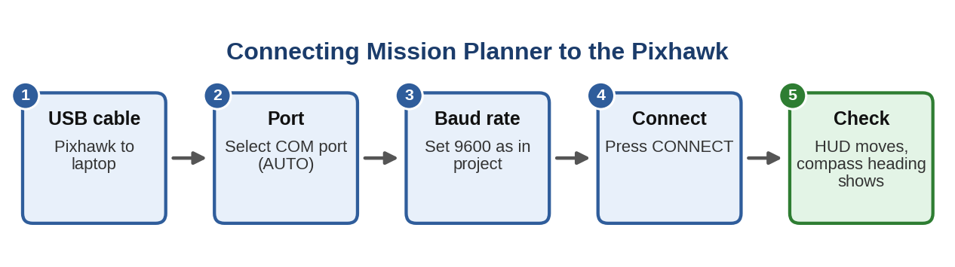
Figure 24: Connecting Mission Planner.
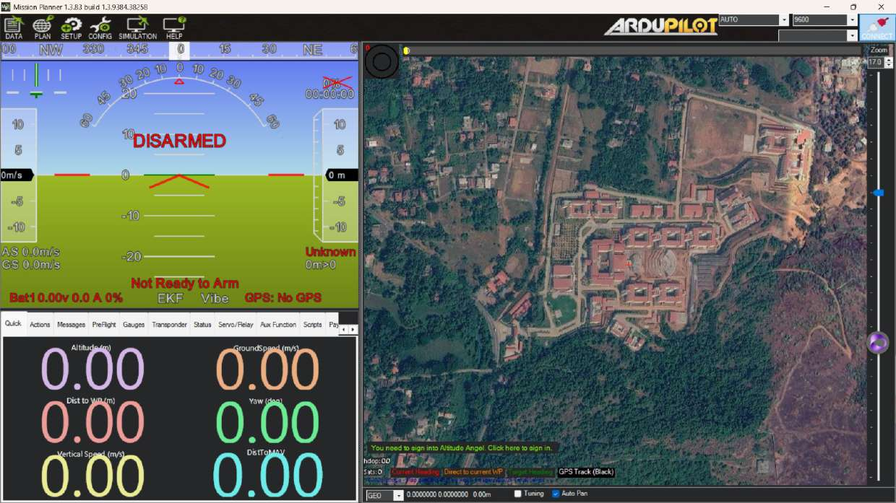  Figure 25: Before connecting: DISARMED, no GPS. | 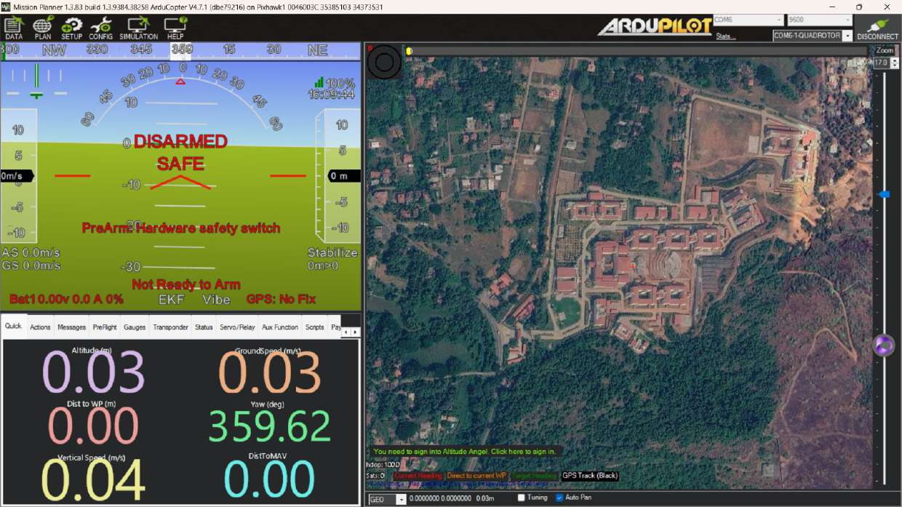  Figure 26: After connecting: Pixhawk detected, safety switch pre-arm message.

8.2 Installing the firmware
Firmware can only be installed while disconnected. Press DISCONNECT first, then open SETUP, Install Firmware, choose the ArduCopter quadcopter firmware and wait for the installation to finish. Reconnect and check the version.
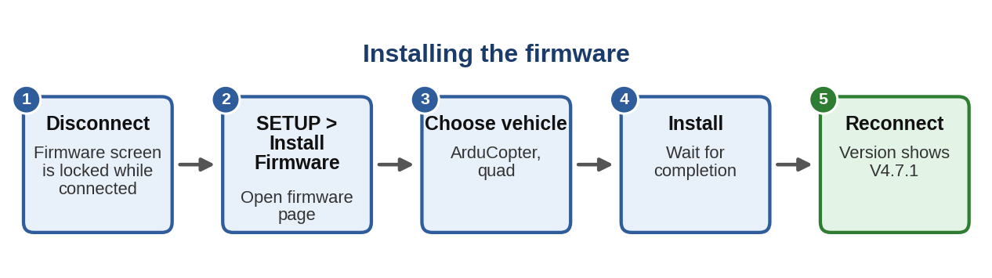
Figure 27: Installing the firmware.
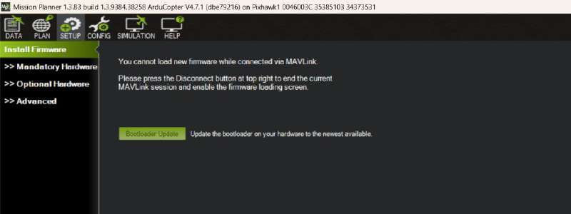
Figure 28: The Install Firmware page refuses to load firmware while the MAVLink connection is open.

8.3 Frame type
Under SETUP, Mandatory Hardware, Frame Type, select the Quad class and the X type. This tells the Pixhawk the motor layout, numbering and directions in Table 7.
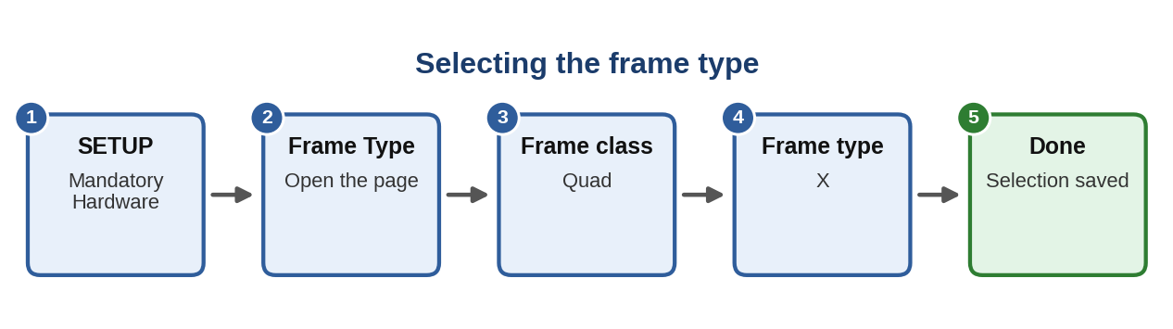
Figure 29: Frame type selection.
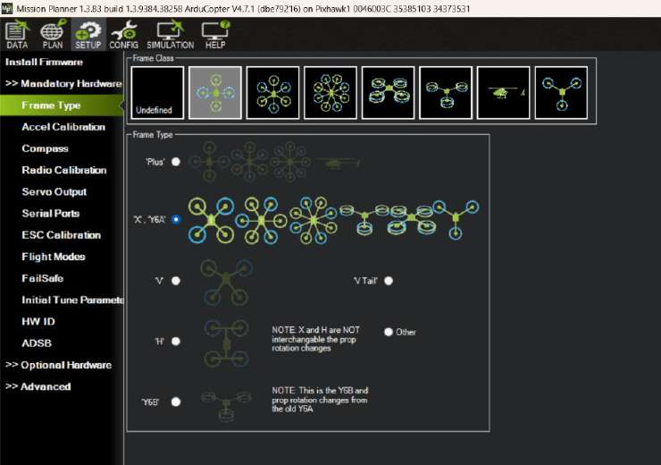
Figure 30: Frame Type page with the X layout selected.

8.4 Accelerometer calibration
The accelerometer calibration teaches the Pixhawk what level is and corrects sensor errors. Click Calibrate Accel, place the drone in each position that Mission Planner asks for (level, left, right, nose down, nose up, back), hold it still each time and click when ready. Then use Calibrate Level with the drone flat on a level surface. Reboot when finished.
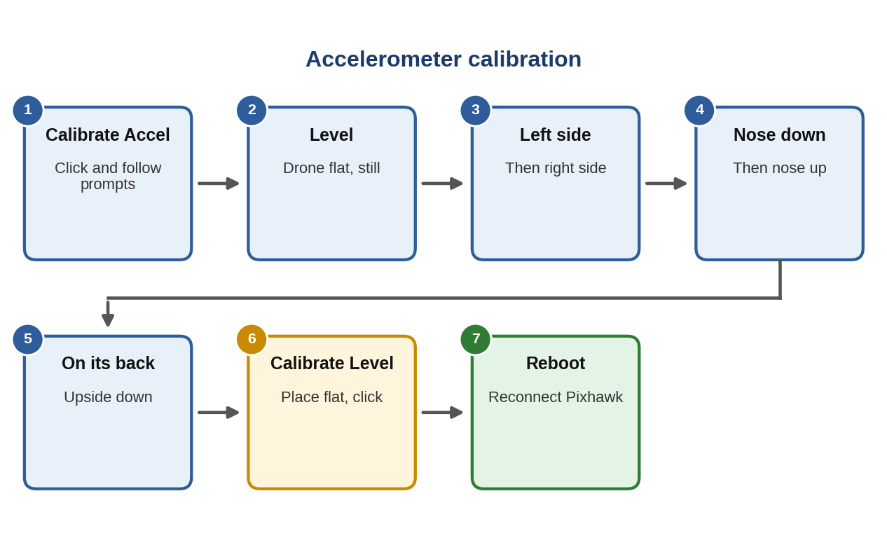
Figure 31: Accelerometer calibration.
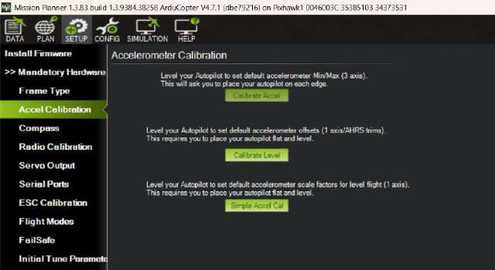
Figure 32: Accelerometer Calibration page.

8.5 Compass calibration
The compass gives the drone its heading, and calibration removes the effect of nearby metal and wires. Two compasses are used: the internal LSM303D (SPI) and the external HMC5883 in the GPS module (I²C). Do this outdoors, away from vehicles, steel structures and mobile phones. Press Start and rotate the drone through all orientations, including level, on each side, nose down and upside down, until both progress bars are full. Then accept and reboot.
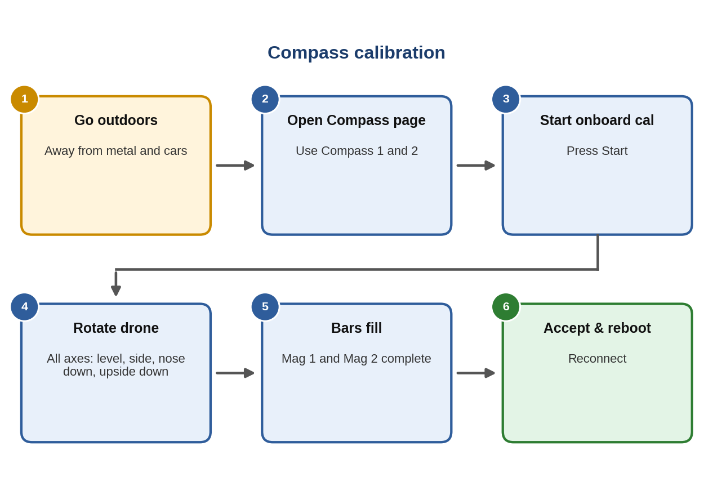
Figure 33: Compass calibration.
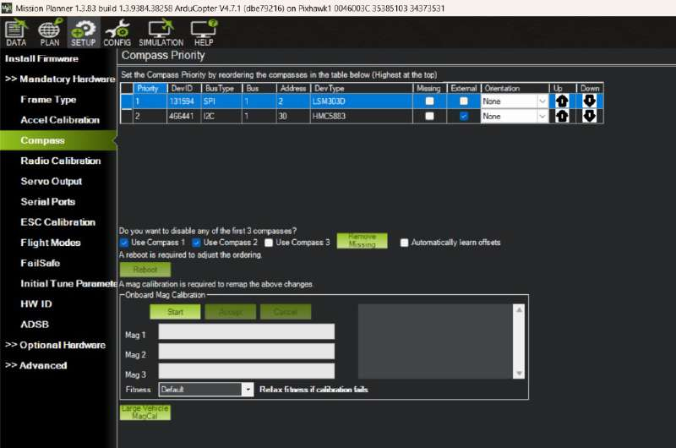
Figure 34: Compass page showing both compasses enabled.

8.6 Radio calibration
Switch on the transmitter, open Radio Calibration and click Calibrate Radio. Move both sticks and all switches to their extremes so that Mission Planner records the minimum and maximum of every channel, then click to finish. Check that the bars for Channels 1 to 4 and 5 move as you move the controls.
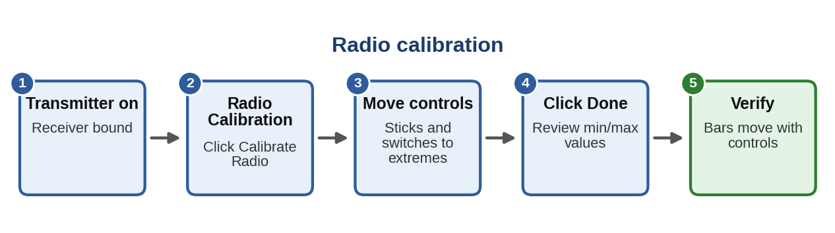
Figure 35: Radio calibration.
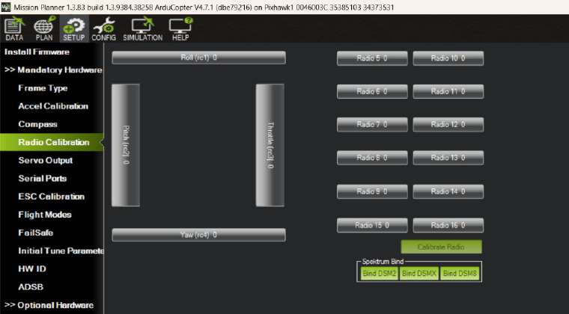
Figure 36: Radio Calibration page.

8.7 ESC calibration
ESC calibration teaches all four ESCs the same minimum and maximum throttle, so the motors respond identically. Remove all propellers first. The project tried the Mission Planner method but the result was not accurate, so the transmitter method in Figure 37 was used and worked correctly. It is important that the ESCs see full throttle during the process, or they will not learn the top of the range.
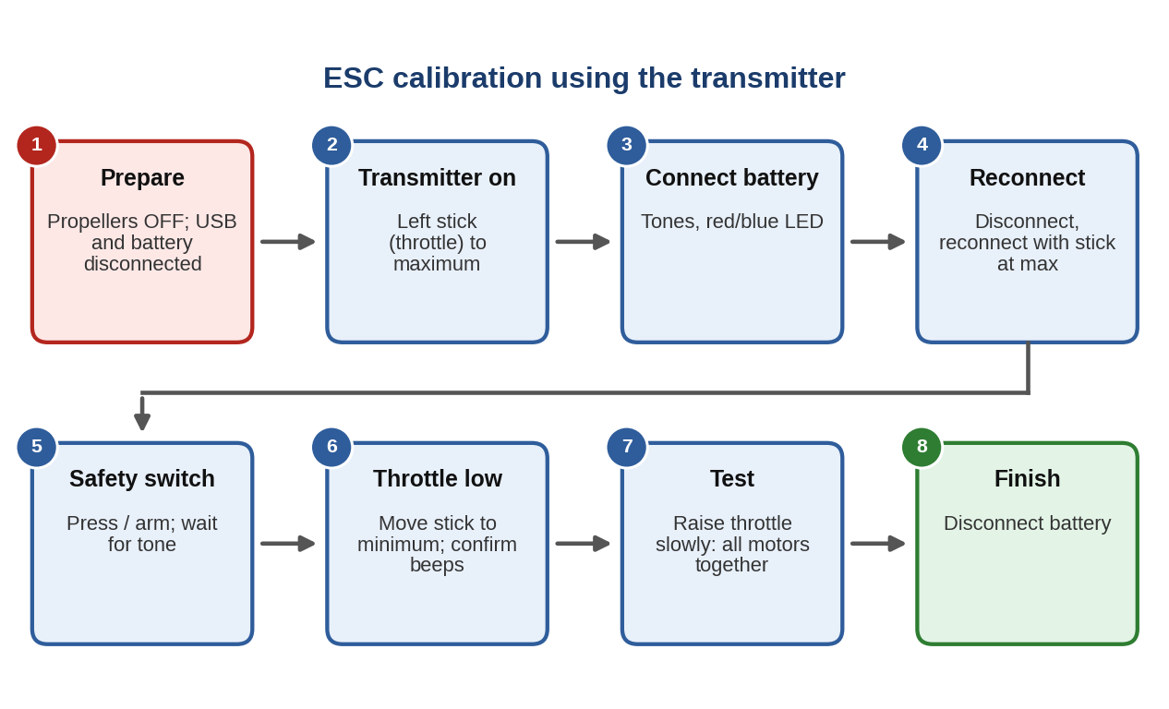
Figure 37: ESC calibration using the transmitter, as carried out in the project.
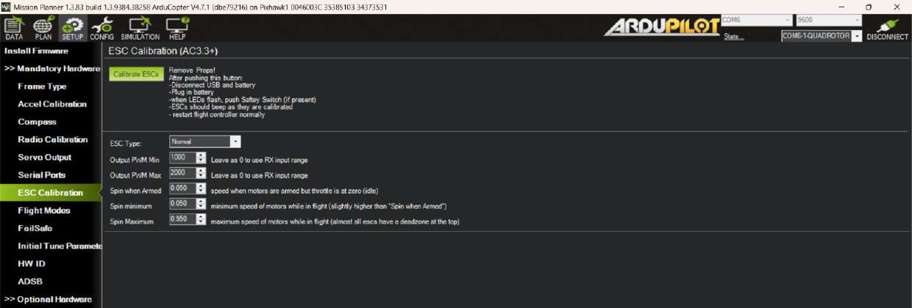
Figure 38: ESC Calibration page. The on-screen method: remove props, disconnect USB and battery, connect the battery, press the safety switch when the LEDs flash, and wait for the ESC beeps.
Check the ESC manual. Calibration procedures differ between ESC models. Follow the maker’s instructions for your ESCs if the beep patterns differ from the sequence shown.

8.8 Flight modes
The Pixhawk selects a mode from the PWM value of Channel 5. Table 9 shows the bands in Mission Planner. The three positions of SwB were set to Stabilize (low), Loiter (middle) and RTL (high). Move the switch and check that Current Mode changes, then click Save Modes.
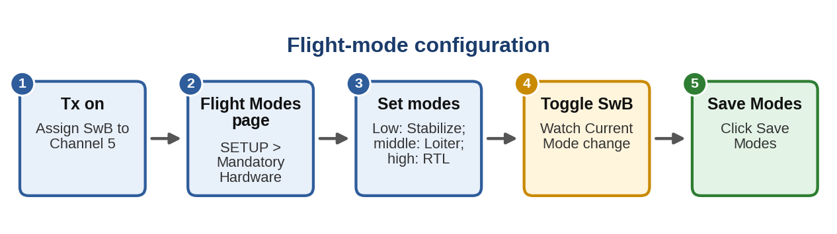
Figure 39: Flight-mode configuration.
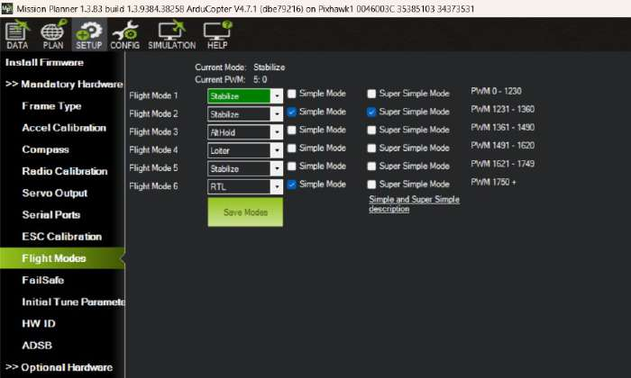
Figure 40: Flight Modes page.
Table 9: Mission Planner flight-mode bands for Channel 5
PWM range | Mode slot | Mode set
0 to 1230 | Flight Mode 1 | Stabilize
1231 to 1360 | Flight Mode 2 | Stabilize
1361 to 1490 | Flight Mode 3 | Alt Hold
1491 to 1620 | Flight Mode 4 | Loiter
1621 to 1749 | Flight Mode 5 | Stabilize
1750 and above | Flight Mode 6 | RTL

Check. The middle switch position gives a PWM close to 1500, which is just inside the Loiter band (1491 to 1620). Confirm on the page that Current PWM stays in that band. Also check that the Simple and Super Simple boxes are only ticked where intended: in the screenshot they are ticked for some slots.

8.9 Failsafe
Failsafes protect the drone if the radio link or the battery fails. Two kinds are used: the transmitter failsafe in Section 7 and the Pixhawk failsafe options on the Mission Planner FailSafe page. Enable the radio (throttle) failsafe and set battery low-voltage values there. If they are not set, the failsafe will not work properly. This was one of the issues found in the project (Section 10).

8.10 Initial tune parameters
This page calculates safe starting values from the propeller size and battery. The values used were: propeller size 10 in, 3 cells, battery type Li-ion, fully charged voltage 4.1 V and fully discharged voltage 2.8 V per cell. Click Calculate Initial Parameters, review the changes in the window that appears and write them to the Pixhawk.
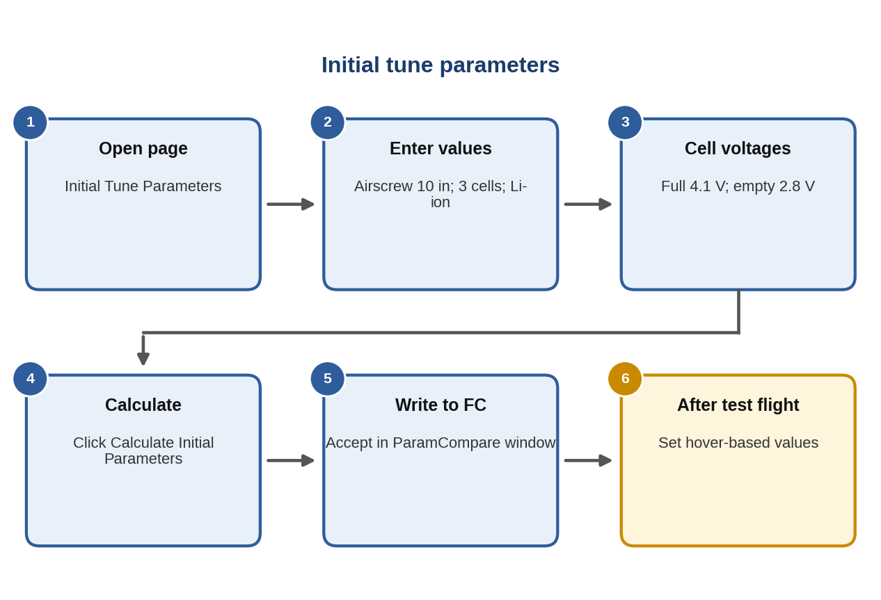
Figure 41: Initial tune parameter flow.
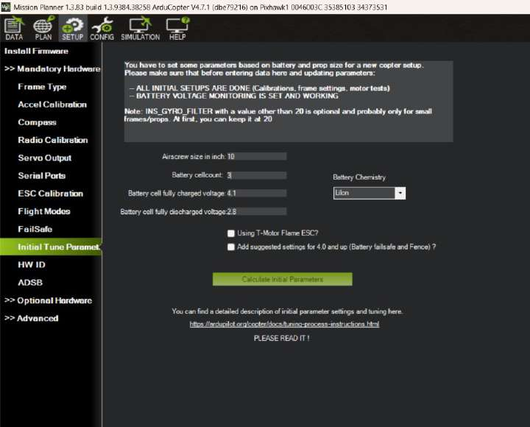  Figure 42: Entered values. | 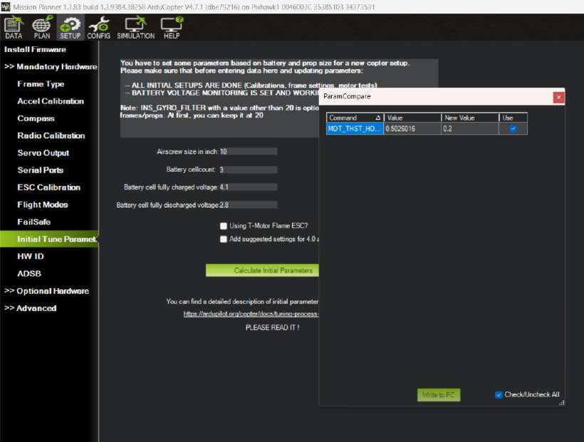  Figure 43: Parameter changes to be written.

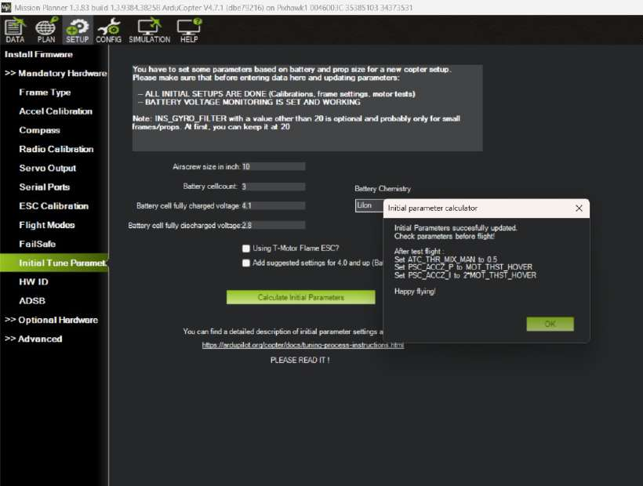
Figure 44: Confirmation. After the first test flight, set ATC_THR_MIX_MAN to 0.5, PSC_ACCZ_P to MOT_THST_HOVER and PSC_ACCZ_I to 2 × MOT_THST_HOVER.
Battery limits. The voltage limits let the Pixhawk compensate thrust as the battery drains. They are not a failsafe by themselves, and the option to add the suggested battery failsafe and fence settings was not ticked, so set battery failsafes separately on the FailSafe page. If the pack is actually LiPo, select LiPo and use a minimum of about 3.3 V per cell.

8.11 Motor test
The motor test checks that every motor spins and turns the right way. Remove the propellers, connect the battery, open SETUP, Optional Hardware, Motor Test, set throttle to 5 % and duration to 2 s, then test motors A to D in turn. Compare each motor’s direction with Table 7. If one is wrong, disconnect the battery and swap any two of its three wires, then test again. The motor test should be done whichever ESC calibration method was used.
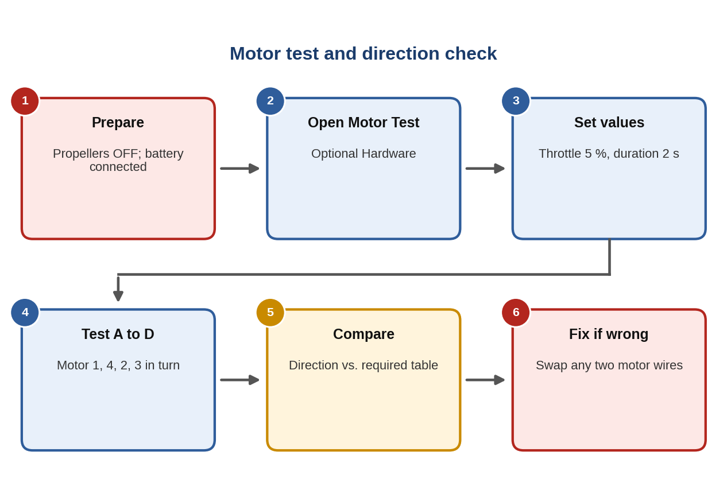
Figure 45: Motor test and direction check.
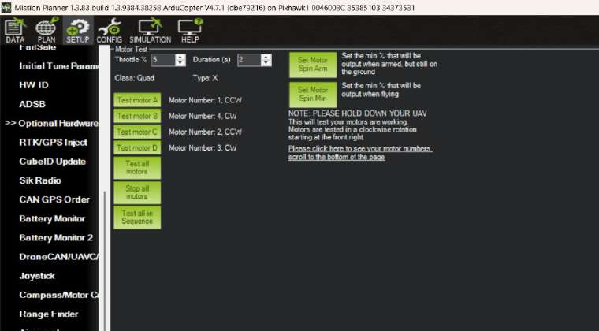
Figure 46: Motor Test page: motor A is number 1 (CCW), B is 4 (CW), C is 2 (CCW), D is 3 (CW).

9. Flight Procedure
All calibration must be done outdoors where GPS is available, since indoor calibration can give wrong GPS and compass results. Do not move the drone while the battery is being connected and the radio is connecting, or the calibration can be lost.
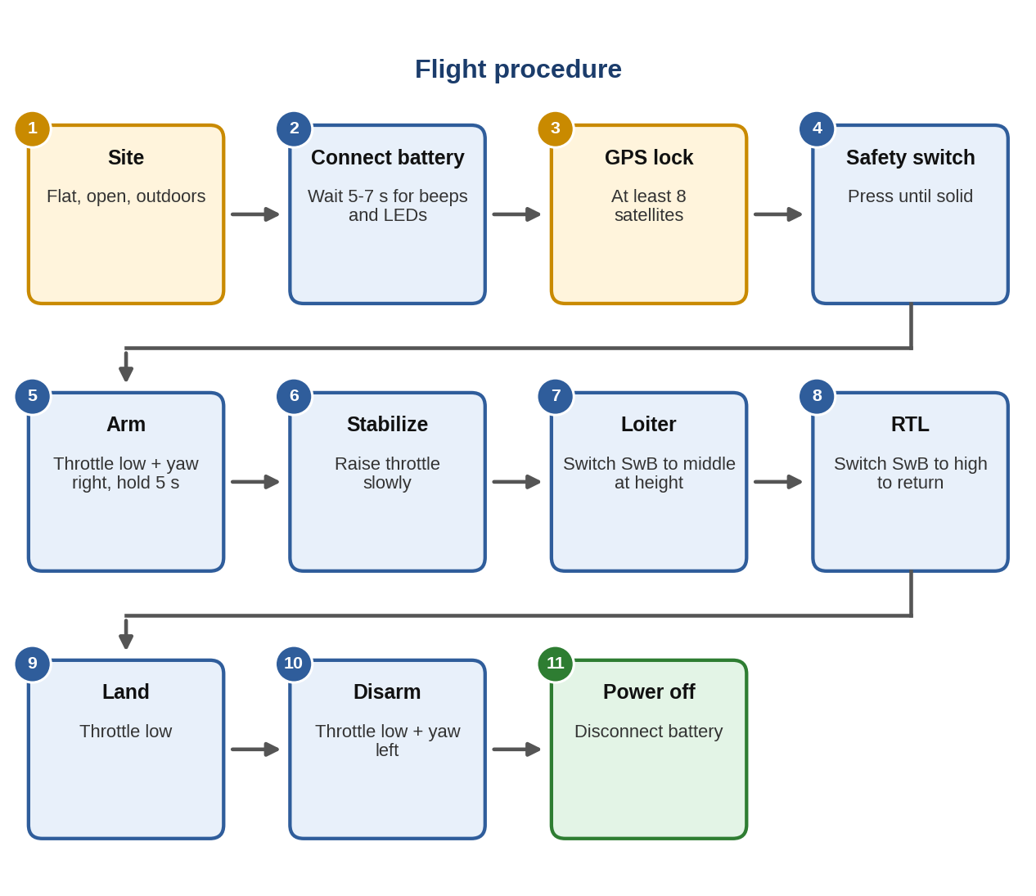
Figure 47: Flight procedure from battery connection to power off.

Start-up
- Place the drone on a flat, open outdoor surface and connect the battery.
- After about 5 to 7 seconds the Pixhawk beeps and the LED shows green and yellow while the system starts. Wait for GPS lock (at least 8 satellites).
- Press the safety switch, then arm using the left stick at the lower right corner for 5 to 6 seconds, until the Pixhawk shows green and the motors beep.

Flying
- Start in Stabilize with SwB low. Raise the throttle slowly until the drone lifts off.
- At a safe height switch to Loiter. The drone holds its position, and you can move it forward, back, left, right and up or down.
- To bring it back, switch to RTL. The drone climbs to the RTL altitude (about 10 m in the project), flies home and descends.

Shutting down
- Land and bring the throttle fully down, then hold the left stick at the lower left corner to disarm. Then disconnect the battery.

10. Problems Faced and Solutions
Table 10: Problems and solutions
Problem | Cause | Solution
ESC calibration not accurate | Calibrated through Mission Planner | Calibrate with the transmitter at full throttle
ESCs not responding | ESC signal leads on AUX OUT (PWM for other uses) | Connect them to MAIN OUT 1 to 4
GPS not working | GPS wired as CAN; this module is not a CAN device | Connect to the GPS port and the compass to I²C
Radio will not connect or drone will not arm | GPS lock too weak, safety switch not pressed or radio not detected | Fly outdoors with 8 or more satellites, press the safety switch and check radio calibration
Failsafe does not work | Failsafe and initial tune parameters not set | Set both before flying (Sections 8.9, 8.10)
Calibration lost | Drone moved while connecting the battery and radio, or after a crash | Keep it still while connecting; recheck calibration after every crash
Wrong direction or drifting | GPS and Pixhawk arrows not pointing the same way | Align both arrows to the front
Parts loosened in flight | Thrust and vibration | Tighten screws and propeller nuts before each flight
Solder joint failure | Weak joints with high current | Make solid, rounded joints and inspect them
Difficult first flight | Wrong order of modes | Take off in Stabilize, switch to Loiter at height, return with RTL

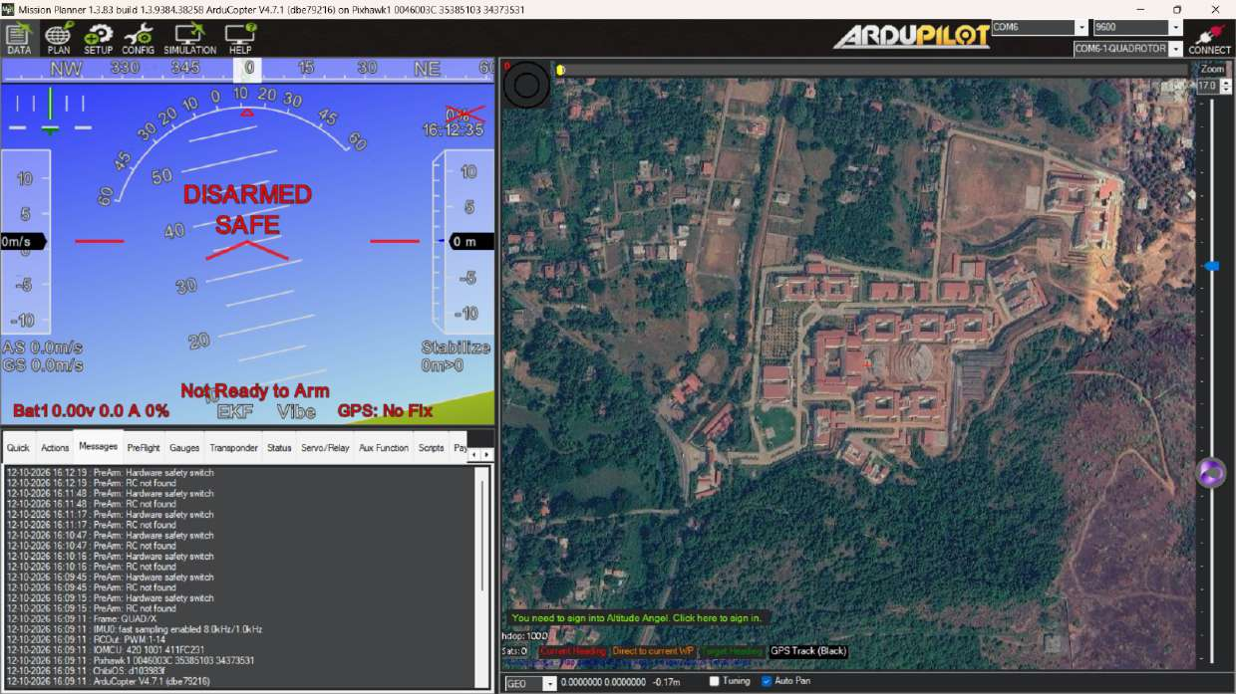
Figure 48: Pre-arm messages: “PreArm: RC not found” and “PreArm: Hardware safety switch”. These appear when the radio is not detected or the safety switch has not been pressed.

11. Safety Precautions

Before powering on
- Disconnect the battery before soldering, changing wiring or swapping motor wires.
- Check battery polarity, solder joints, ESC and power module wiring.
- Check motor order, direction and propeller type.

During calibration and testing
- Remove all propellers for ESC calibration, motor tests and any bench work with the battery connected.
- Calibrate the compass and GPS-related items outdoors.
- Keep the drone still while connecting the battery and radio.

Before and during flight
- Check failsafes, arming and the RTL settings.
- Fly in a clear open area, with people at a safe distance, and keep the drone in sight.
- Follow the applicable drone rules, check the Digital Sky zone map, and use an experienced pilot for first flights.

12. Conclusion
A quadcopter was assembled and configured around a Pixhawk 2.4.8 with four BLDC motors and ESCs, an M8N GPS with compass, and a FlySky FS-i6S radio. After mechanical assembly and wiring, the transmitter was bound and set up, and Mission Planner was used to install the firmware, select the frame, calibrate the accelerometer, compass, radio and ESCs, set flight modes, failsafes and initial tune parameters, and test the motors.
The drone flew in Stabilize, held position in Loiter and returned with RTL. The main lessons were to calibrate ESCs from the transmitter, wire ESCs to MAIN OUT, connect the GPS to the right ports, keep GPS and Pixhawk aligned, set failsafes before flying, and recheck calibration after any crash.

Future scope
- Add a telemetry radio for live monitoring and parameter changes in flight.
- Tune the controller further, for example with Auto Tune.
- Plan and fly autonomous waypoint missions in Mission Planner.
- Add a camera or gimbal and measure the effect on flight time.
- Log flights and analyse vibration, battery use and RTL accuracy.

Appendix: Values to Confirm Before Submission
Table 11: Items to verify
Done | Item
☐ | All-up weight (the notes mention both about 2.5 kg and 5 kg) and the payload capacity.
☐ | Radio range figure (reported 2 to 3 km) against the FS-i6S specification.
☐ | Battery label: chemistry (Li-ion or LiPo), capacity and burst current; set the cell voltages to match.
☐ | ESC model and calibration instructions (notes mention both Cyclone 35 A and SimonK).
☐ | Propeller markings and the correct propeller for each motor direction.
☐ | RTL altitude set in Mission Planner (RTL_ALT), reported as about 10 m.
☐ | Radio and battery failsafe settings on the Mission Planner FailSafe page.
☐ | Current Drone Rules and Digital Sky zone for the flying site.

